Name: Sahasra V
Reg no: 192424234
Course:CSA1209 Computer Architecture

- To write an assembly language program to implement 8-bit addition using 8085 processor.

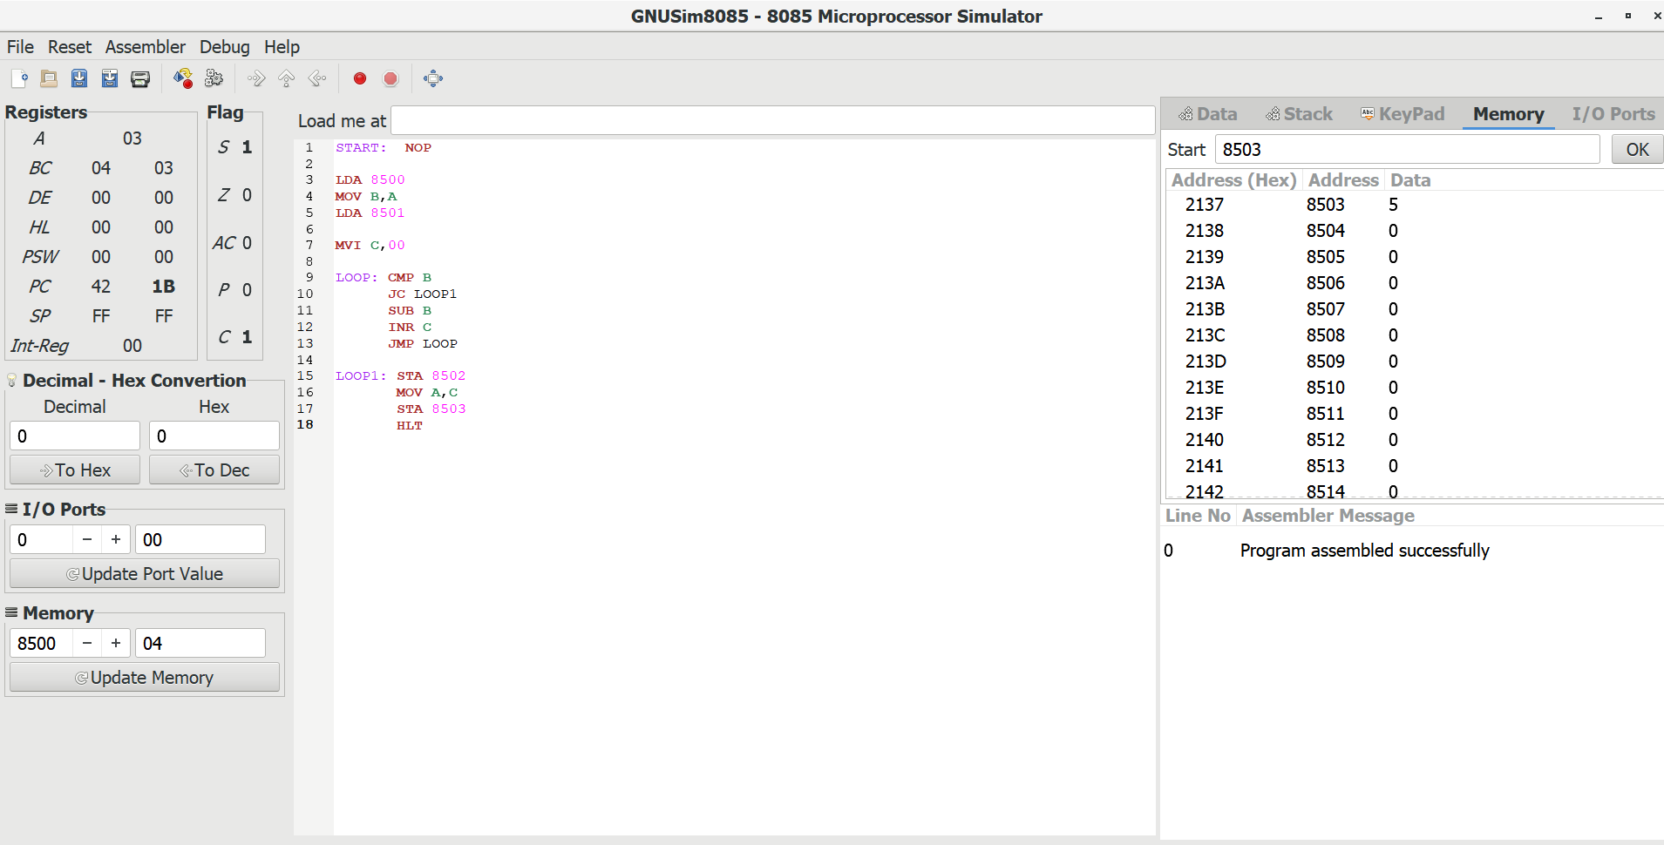

- To write an assembly language program to implement 8-bit subtraction using 8085 processor.

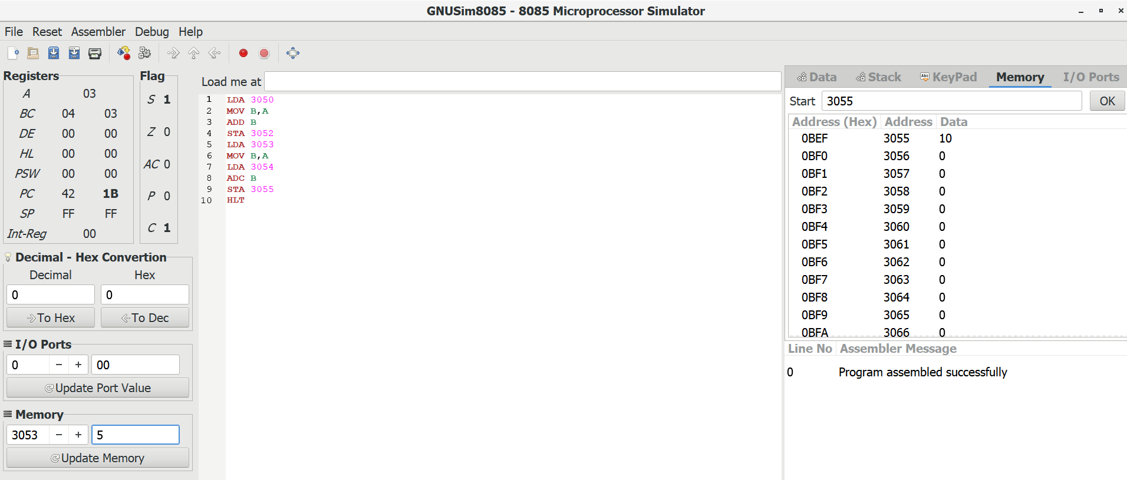

- To write an assembly language program to implement 16-bit subtraction using 8085 processor.

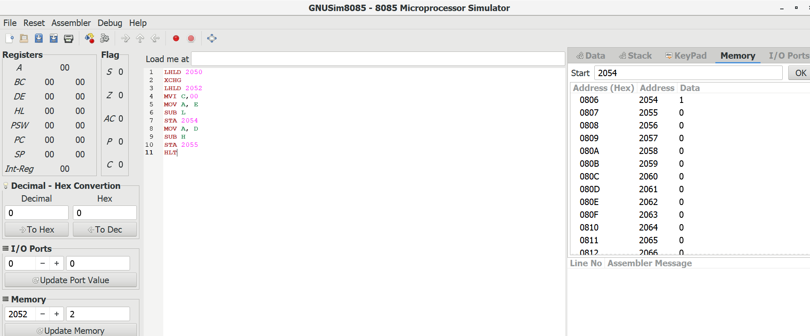

- To write an assembly language program to implement 16-bit multiplication using
8085 processor.

